Insight
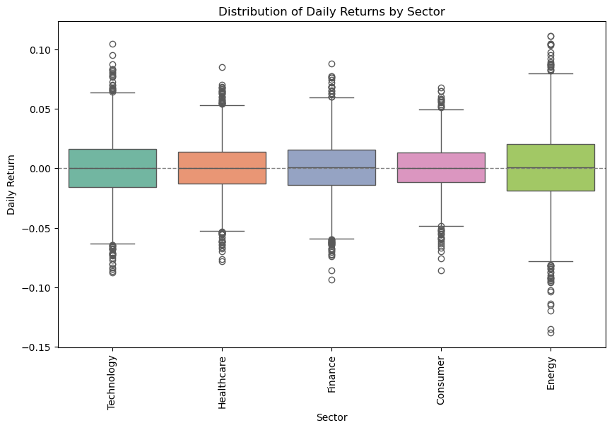
Interpretation of Summary Table
- Top Performers (Higher Mean Return):
STK001 (0.0018) and STK014 (0.0015) show the strongest average daily gains (~0.18% and ~0.15% respectively).
These stocks may be in stronger uptrends over time.

- Underperformers (Negative Mean Return):
STK002 (-0.0004), STK007 (-0.0002), STK016 (-0.0001), and STK019 (-0.0008) have slightly negative means — indicating small daily declines on average.

- Volatility Insights:
The most volatile stocks are STK017–STK020 (std ≈ 0.03) — they experience the largest daily swings.
The most stable are STK013–STK016 (std ≈ 0.018–0.019) — they show smaller, steadier changes.

Typical Returns (Median):
Most medians are ≈ 0.0000–0.0010, meaning many stocks have flat or small positive daily movements — normal for liquid, stable assets.

Most stocks show modest average daily gains (0.05–0.15%) and low-to-moderate volatility (std 0.02–0.03).
A few (like STK017–STK020) are more volatile, while STK001 and STK014 stand out as consistent gainers.

Volatility
Analysis of sector performance shows that the Finance and Consumer sectors achieved the highest average returns, indicating strong and consistent growth. The Consumer sector also recorded the lowest volatility, suggesting lower investment risk. In contrast, the Energy sector exhibited the highest volatility and the lowest average return, reflecting its sensitivity to market and commodity price fluctuations. Technology and Healthcare sectors maintained moderate returns with manageable risk levels, with Healthcare standing out for its relative stability, typical of defensive industries. Overall, Finance and Consumer sectors offered the best balance between risk and reward during the analysis period. From the boxplot visual, we can see that Energy sector has a wider box which indicate volatility.

Volume Analysis
Across all tickers, the correlation between trading volume and daily returns remains weak, ranging from –0.06 to +0.06. This suggests that trading volume does not systematically predict price direction in the observed period. While a few stocks show slightly positive or negative tendencies, these relationships are too small to be meaningful. Therefore, price movements in this dataset appear largely independent of volume fluctuations.

Technical Indicators Insight
Price touching or exceeding the upper band indicate overbought conditions while crossing below the lower band suggests oversold levels.

The RSI(14) plot for the selected stock shows several peaks above 70, indicating overbought conditions followed by short-term price corrections. Occasional dips below 30 suggest oversold periods where the stock may have been undervalued before rebounding. Overall, the RSI pattern highlights alternating phases of buying and selling pressure, consistent with cyclical market behavior.

Correlation Summary of Technical Features
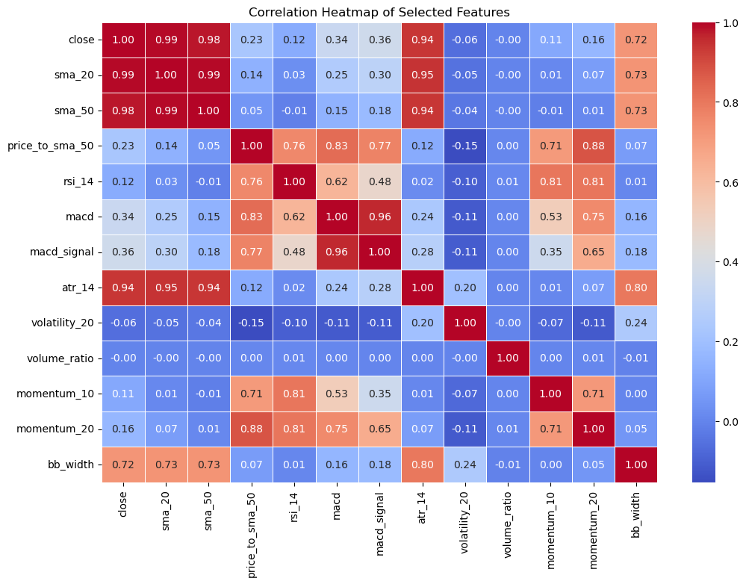
Price and Moving Averages:
close, sma_20, and sma_50 are very highly correlated (>0.97), indicating they move together closely.
price_to_sma_50 has moderate correlation with rsi_14 (0.76) and macd (0.83), reflecting its relation to momentum indicators.

Momentum Indicators:
rsi_14 and momentum_10/20 show strong positive correlation (~0.80), confirming they capture similar price strength signals.
macd and macd_signal are extremely correlated (0.96), as expected from the MACD calculation.

Volatility Measures:
atr_14 correlates strongly with bb_width (0.80) and with price/MAs (~0.94), indicating that volatility increases with price movement magnitude.
volatility_20 has low correlations with most features except bb_width (0.24), showing it measures a slightly different aspect of price variability.

Volume and Returns:
volume_ratio shows nearly zero correlation with other features, suggesting volume-based signals are largely independent.

Bollinger Bands
bb_width is strongly correlated with atr_14 and moderately with close/MA features (~0.72), reflecting how bands widen during high volatility.

Key Insights:
Features like close, sma_20, and sma_50 are redundant, so including all in a model may cause multicollinearity.
Momentum indicators (rsi_14, momentum_10/20, macd) are highly correlated; you might select 1–2 for modeling.
Volume (volume_ratio) is independent, adding a unique dimension to predictive models.
Volatility indicators (atr_14, bb_width) capture similar information, but volatility_20 is complementary.

